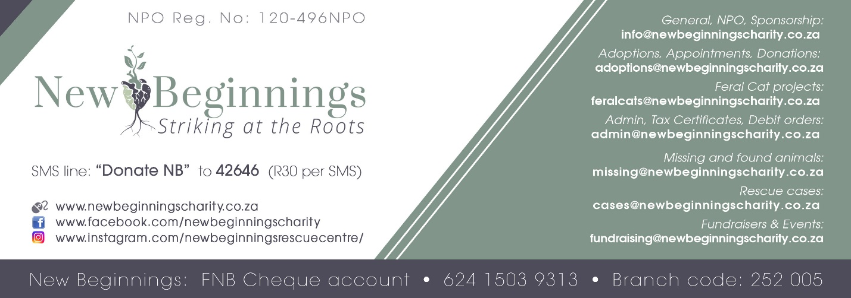

Please fill in the following in order for us to issue you with a Tax Certificate.

Company / Person Name:
Company Registration Number:
VAT Number:
If not company, ID Number:
Physical Address:
Contact Number:
E-mail Address:
Date of payment:
Amount donated:
Is this by debit order: | Y/N
Were these EFT’s | Y/N
 | If EFT, please attach proof of payments to request form

Once New Beginnings receives this, you will receive your certificate within 3-5 working days.
Important note, if you do not have a debit order with us, please supply a summary of your payments from your bank account. We cannot issue the certificate without it.

Regards
New Beginnings Management

